Deirdre Gabbay
Shmita in Seattle
www.shmitainseattle.com
5780 – The Year of Environmental Teshuva
The “How to Care” Workbook

5780 – The Year of Environmental Teshuva “How to Care” Workbook
As we settle into a new year, whether it be on the Jewish or the secular calendar, there is a natural inclination to try to bring the reality of how we actually live into alignment with our intentions.
This little workbook that you are holding is intended to help each of us take the next practical step for us, to bring our behavior into alignment with our intentions and goals. It feels satisfying to check items off a to-do list, so we are providing exactly that – a to-do list for the Earth, with boxes to check to keep track of progress.
There is no need to try to tick off every single item on these pages; if this workbook inspires you to develop even one new pattern of behavior this year, or connects you to new resources, it will have made a difference.
You will find additional resources in the back of the booklet relating to items with asterisk*.
This is a first edition. We make no claim to be comprehensive, nor have we reviewed every business or product mentioned. The workbook will be revised. Please reach out if you have suggestions for improving this document in any way. An online copy can be found on the Resources page at:

Shmita in Seattle
“Bringing Shmita Values to Life in Seattle”
www.shmitainseattle.com

Enjoy! Deirdre Gabbay

Table of Contents
5780 – The Year of Environmental Teshuva “How to Care” Workbook 1
Consumer Products 3
Food Shopping 4
Recycling – If You’re Gonna do it, do it *Right* 5
Lawn and Garden Care 6
In the Home 7
Getting Around 8
Support or Join Local Conservation and Activist Organizations 9
Take Part in Environmental Restoration 10
Banking and Investing 10
Love Nature 11
Organize Your Neighborhood 12
Organize Your Faith Community 12
Participate in Collective Actions 13
Resources 14
Local Shopping Guide 14
Online Companies Specializing in Waste Reduction 16
Companies Selling Carbon Offsets 17
A Few of the Many Regional CSAs with Drop-offs in the Seattle Area 17

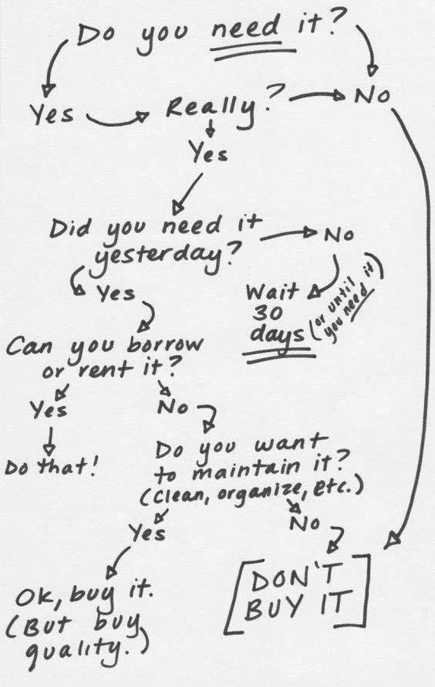
Consumer Products
Thoughtfully choosing to utilize only what we truly need, trying to purchase products that are durable and long lasting, can reduce our impact today and in the future. This reminds me of the types of mitzvot which bring rewards “both now, and also in the world to come…”
See our Shopping Guide* and list of Online Companies Specializing in Waste Reduction* for ideas of where to purchase the type of sustainable products mentioned here, locally or online.
- Buy less new stuff (if you have a need, try looking for it at Buy Nothing on Facebook, a consignment shop, or at Goodwill, etc.)
- Reduce plastics in the home
  - Hand Soap (switch from liquid to bar soap)
  - Shampoo (switch from liquid to bar shampoo*)
  - Laundry Detergent (various options, including Dropps*)
  - Detergent for washing dishes by hand (there is a bar variety, also a cardboard box)
  - Produce bags (switch to reusable)
  - Food wrap (use silicon, beeswax wrap, or ceramic/glass storage)
  - Toothbrush (switch to bamboo, Zero Waste Cartel*, e.g.)
- Use cloth napkins
- Assign a unique glass to each household member to reduce re-washing of water glasses
- Purchase paper products that aren’t made from old growth forests (Who Gives a Crap*, e.g.) or refer to the graphic in the Resources section for commercial paper products with less impact

Food Shopping
The percentage of our climate impact directly attributable to food choices is substantial.
- Eat less meat (eat lower on the food chain and ramp down meat consumption this year)
- Buy local food when it is in season (and avoid imported, out of season food)
- Choose organic produce
- Avoid waste when shopping by bringing reusable produce and grocery bags
- Try shopping in a store that allows you to bring your own container* for bulk purchases
- Take part in a Community Supported Agriculture* (CSA) program
- Grow your own fruit, herbs or vegetables

Notes:
- ____________________________________________
- ____________________________________________
- ____________________________________________
- ____________________________________________
- ____________________________________________

Recycling – If You’re Gonna do it, do it *Right*
- Learn what can and can’t be recycled curbside and resolve to place in your recycle bin only what can really be recycled. (Better to toss than compromise the system.)
- Ridwell is a local small business that can help recycle some of the more challenging items conveniently (plastic film, unusable fabric material (threads), batteries, lightbulbs, Styrofoam; as well as collecting items for donation, and specialized pickups, such as electronics, on a rotating basis, from your doorstep. www.ridwell.com
- ReCology is the company that collects recycling curbside in Seattle and Shoreline. Their stores accept items that cannot be picked up curbside: CFL light bulbs, household batteries, old textiles, hard-cover books, small electronics and appliances, block Styrofoam™, latex paint, and bicycles. Drop-offs are free if you bring them to the store (in Seattle for Seattle residents or the Shoreline store for Shoreline residents) or fee-based if you bring them to the wrong store. www.recology.com/
- Electronics recycling resources can be found at Washington State Department of Ecology https://ecology.wa.gov/Waste-Toxics/Reducing-recycling-waste/Electronics
- Donate gently used clothing to shelters (Mary’s Place, Treehouse, Eastside Baby and Westside Baby for children’s clothes, Queen Anne Helpline for adult clothing)
- Unusable and damaged clothing will be recycled if you bring it to Goodwill

Lawn and Garden Care
The Seattle Public Utilities Website is a wealth of information about responsible lawn and garden care. It also has information about rebates available for rainwater harvesting through their RainWise program, for installing efficient irrigation systems, and more.
http://www.seattle.gov/utilities/environment-and-conservation/lawn-and-garden
- Build Healthy Soil - Learn how to make and use compost and mulch, fix soil problems, and fertilize responsibly.
- Choose the Right Plants for Your Site - Find plants that match the conditions in your yard. Learn how to plant and care for them.
- Practice Smart Watering - Learn how to water for healthier plants, how to use soaker hoses, drip and automatic irrigation systems efficiently, and get rebates for irrigation system upgrades.
- Use Natural Pest, Weed and Disease Control Methods - Learn how to identify and control pests and weeds without chemicals.
- Practice Natural Lawn Care - Learn how to grow a healthy lawn with less water, chemicals, and work!
- Food Gardening - Learn about growing food year ‘round in our Northwest climate: soil, seeds, planting, harvesting, and community gardening resources.
- Install a rain garden and/or cisterns to clean and slow runoff. You may qualify for a subsidized RainWise rain garden or cisterns from King County. www.seattle.gov/utilities/environment-and-conservation/projects/green-stormwater-infrastructure/rain-wise

In the Home
- Get a free home energy assessment from Puget Sound Energy
www.pse.com/rebates/home-energy-assessment
- “Green Up” your Seattle City Light bill to add renewable capacity to the system https://energysolutions.seattle.gov/renewable-energy/green-up/
- Replace an aging appliance and get a rebate from Seattle City Light or Puget Sound Energy https://energysolutions.seattle.gov/your-home/rebates/ or
www.pse.com/Rebates
- Replace a toilet or hot water tank and receive a rebate from Seattle Public Utilities www.seattle.gov/utilities/services/water/reduce-water-use/water-saving-rebates
- Light bulbs (switch to LEDs)
- Turn off lights and/or use timers and motion sensors
- Home Heating (install a thermostat with a timer)
- Home Heating (switch to electric from gas or oil)
- Water Heating (switch to a higher efficiency heater when upgrading)
- Showers (switch to very low flow shower heads (available free from SPU) or at least do not use a “rain shower” type shower head)

Notes:
- ____________________________________________
- ____________________________________________
- ____________________________________________

Getting Around
If you dropped a bubble over the state of Washington, the largest contributor to the greenhouse gasses would be transportation, at about 40%.
- Replace a repeating vehicle trip with a walk, bus or light rail ride. Try the online King County Metro Trip Planner or Sound Transit Trip Planner to find out if there is a bus going where you want to go. https://tripplanner.kingcounty.gov/ or https://www.soundtransit.org/tripplanner
- Try bicycle commuting. Bicycle commuting has increased dramatically in Seattle as bicycle lanes are drawn and protected (somewhat) from vehicles
- Invest in a power-assist bicycle to make Seattle’s hilly terrain more manageable
- If transit doesn’t connect you to where you want to go, write a letter to the transit agency
- Upgrade your vehicle to hybrid or electric, or to a higher-mileage vehicle
- Reduce air travel (Take leadership: suggest using Skype to teleconference rather than meet)
- Purchase carbon offsets for air travel*

Notes:
- ____________________________________________
- ____________________________________________
- ____________________________________________

Support or Join Local Conservation and Activist Organizations
- City Fruit www.cityfruit.org
- Tilth Alliance www.tilthalliance.org
- 350seattle.org www.350seattle.org
- Forterra https://forterra.org/
- Extinction Rebellion https://www.seattlerebellion.earth/#/
- Sunrise Movement https://www.sunrisemovement.org/
- Green Seattle Partnership https://www.greenseattle.org/
- Audubon Society https://www.audubon.org/content/seattle-audubon-society
- Seattle Youth Climate Action Network https://www.sycan.org/
- Plant for the Planet https://www.plant-for-the-planet.org/en/home
- Jewish Climate Action Network https://www.jewishclimate.org
- Earth Ministry https://earthministry.org/ or
- FACT http://www.1sustainableplanet.org/p/faith-and-climate-action.html
- Ahavat v’Avodat HaAdamah by contacting me at deirdre@gabbay.org
- Search for and Join Western Washington Jews Practicing Environmental Teshuva on Facebook

Take Part in Environmental Restoration
Green Seattle Partnership and Forterra regularly lead planting and restoration groups. Bring your friends or find a group through Western Washington Jews Practicing Environmental Teshuvah, or other faith or interest-based organization.
https://forterra.org/service/green-city-partnerships
https://www.greenseattle.org/
- Plant trees
- Restore salmon habitat
- Remove invasive species
- ____________________________________________
- ____________________________________________

Banking and Investing
- Terminate direct investments in the fossil fuel industry (stock ownership of Exxon, e.g., unless you are using this to exert influence over their board as a shareholder)
- Cancel bank accounts with banks that directly fund the fossil fuel industry with your money (JP Morgan Chase, Wells Fargo, Citi, and Bank of America, and Morgan Stanley); be sure to write a letter explaining your decision)
- Directly invest in the green economy – renewable energy, electric vehicle infrastructure, e.g.
- Look at BlackRock and others for sustainable investment opportunities www.blackrock.com/us/individual/insights/blackrock-investment-institute/physical-climate-risks

Love Nature
- Find a hiking buddy
- Hike or walk regularly if you are able
- Take the bus to the trailhead with Trailhead Direct https://trailheaddirect.org/
- Go to the beach
- Camp outdoors
- Garden either at home, with a friend with a yard, or join a P-Patch
- Go skiing
- Go snow shoeing
- Go sailing
- Explore your neighborhood
- Bird watch
- Look at the stars
- Take a class in astronomy, bird watching, or marine ecosystems, etc.
- Put a bird feeder outside and protect habitat for wildlife where you live
- Pray or meditate outdoors on a regular basis
- Bring a trash bag on your adventures so you can leave it better than you found it
- Become a beach docent for the aquarium and teach others about their world
- Do something outdoors that you have never done before

Notes:
- ____________________________________________
- ____________________________________________
- ____________________________________________
- ____________________________________________

Organize Your Neighborhood
- Advocate for complete sidewalks and safe walking routes through Seattle Neighborhood Greenways http://seattlegreenways.org/
- Organize your neighbors to form an Ecodistrict
- Advocate collectively for community solar investment
- Close a street and have a block party
Look into permits and grants available for community organizing through the Seattle Department of Neighborhoods https://www.seattle.gov/neighborhoods/

Organize Your Faith Community
- Install a Rain Garden
- Install Cisterns
- Compost all kiddush lunch items
- Install energy-efficient lighting
- Use only FairTrade certified coffee and tea service
- Install low flow toilets
- Review your supply stream to eliminate waste and reduce plastic
- Assist members of your community to recycle difficult items

Notes:
- ____________________________________________
- ____________________________________________
- ____________________________________________
- ____________________________________________

Participate in Collective Actions
- Sign the petition supporting Seattle’s Green New Deal https://seattlegnd.org/
- Attend a protest
- Write a letter to the editor
- Write a letter to a corporation if you have an issue with a product you use
- Call or write to your representative
- Get friends together and schedule a meeting with your representative (they often like to meet with groups where possible)
- Attend a public meeting
- Speak, from a faith or secular perspective, at a public hearing
- Take part in a citizen committee to give input to proposed legislation

Notes:
- ____________________________________________
- ____________________________________________
- ____________________________________________
- ____________________________________________

Resources

Local Shopping Guide
PCC Community Market
PCC stocks many bulk items such as oils, spices, coffee, tea, sugar, flour and grains, as well as local, in season, organic produce. Their stock is curated carefully to adhere to consistently high standards for environmental protection and customer safety. www.pccmarkets.com
For additional locations please check their website
Fremont: 600 North 34th Street
Seattle, WA 98103
206-632-6811

Greenlake (Aurora): 7504 Aurora Avenue North
Seattle, WA 98103
206-525-3586

West Seattle: 2749 California Ave SW
Seattle, WA 98116
206-485-7185
Scoop Marketplace
Scoop is a zero-waste, all-bulk grocery store that sells dry goods (grains, baking supplies, beans, legumes, nuts, seeds, snacks, herbs, spices, teas, coffee, and more), as well as bulk oils and vinegars, and bulk personal care and household products. Bring Your Own Container. www.scoopmarketplace.com
151 12th Ave
Seattle, WA
(International District Downtown)

Ecocollective
Ecocollective sells a large selection of bulk personal care products (soaps, shampoos, conditioners, facial oils, toners, lotions, creams, and more), household cleaning supplies (laundry detergent, soaps, and more), as well as ingredients for DIYers such as essential oils, clays, apple cider vinegar, and more. https://ecocollectiveseattle.com
5309 22nd Ave NW Suite B
Seattle, WA
(Ballard)
Public Goods and Services
Public Goods and Services sells bulk housekeeping and laundry supplies, personal care supplies, and other items. https://apublicshop.com
3836 California Ave SW
Seattle, WA 98116
(West Seattle)

Notes:
- ____________________________________________
- ____________________________________________
- ____________________________________________
- ____________________________________________

Online Companies Specializing in Waste Reduction
If you find products you like online, consider bringing them to the attention of your favorite in-person store so you can purchase them on a regular shopping trip, rather than placing individual orders. The graphic from NRDC shows ways to reduce the damage from paper products by switching brands.
Zero Waste Store https://zerowastestore.com/
Zero Waste Cartel https://zerowastecartel.com/
Wild Minimalist https://wildminimalist.com/
Package Free Shop https://packagefreeshop.com/
Dropps plastic-free laundry detergent www.dropps.com
Earth Hero https://earthhero.com/
Who Gives a Crap Toilet Paper and Tissues https://us.whogivesacrap.org/
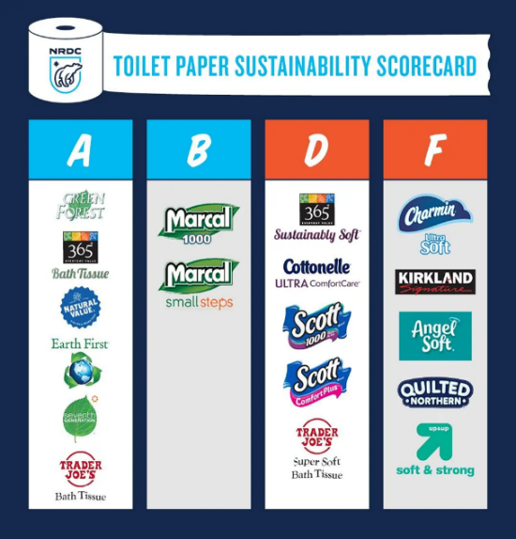
Tushy
hellotushy.com/ products/premium-bamboo-toilet-paper-36-rolls

Companies Selling Carbon Offsets
Carbon Zero www.carbonzero.ca/services
Planet Air https://planetair.ca/en/
TerraPass www.terrapass.com/
CarbonX www.carbonx.ca/

A Few of the Many Regional CSAs with Drop-offs in the Seattle Area
What is a CSA? Community Supported Agriculture provides income directly to organic farmers, and in return, we benefit from fresh, often organic, local produce delivered weekly to local drop off locations.
New Roots Organics https://newrootsorganics.com/
Oxbow Farm & Conservation Center www.oxbow.org/farm/csa/
Helsing Junction Farms www.helsingjunctionfarms.com/
For more listings, here is a great resource: www.localharvest.org/seattle-wa/csa

